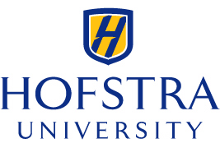
PAY THE PLAYERS
WSC 130 Report

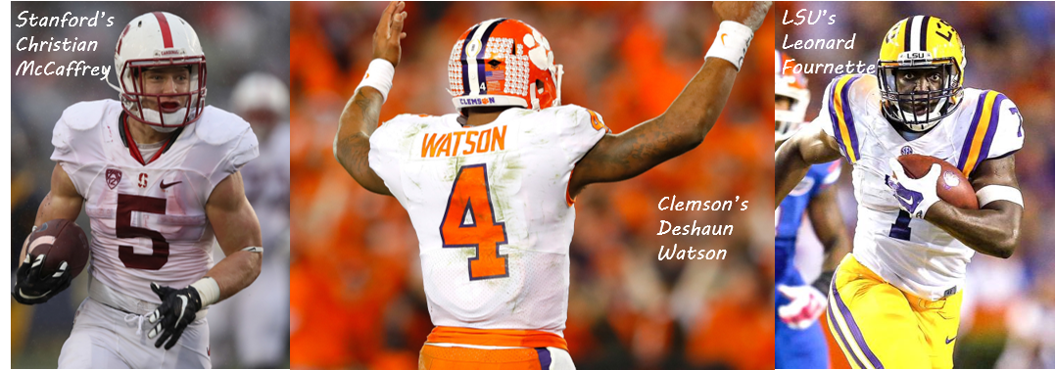

Prepared by Marcus Alexander
Undergraduate Student at Hofstra University

Report Published November 29, 2017

Prepared for
Mark Emmert
National Collegiate Athletic Association
Table of Contents
Executive Summary 3
- Introduction 4
Being A Football Player 4
National Collegiate Athletics Association (NCAA) 4
The Process for Rule Changes 5
- How the Player Lives 6
Students and Student-Athletes 6
Necessity Costs 6
Players Living Without Necessities 9 Food 9
Clothing 10
Living Spaces 11
Football Players’ Schedules 12
Competitive Season 13
Off-Season 14
Summary 16
- How the NCAA Rules 17
Operations 17
Rules and Restrictions 18
Scandals 19
Cam Newton, Auburn 19
Reggie Bush, USC 20
North Carolina Football Players 21
Ohio State Football Players 22
Donald De La Haye, UCF 22
Protecting the Players 23
Injury Costs 24
Scholarships 24
Beyond College Football 26
Summary 28
- Conclusion 29
DI Football Players 29
The NCAA 29
A Change Should Be Made 30
Self-Imposed Change & Forced Change 30
Work Cited 33









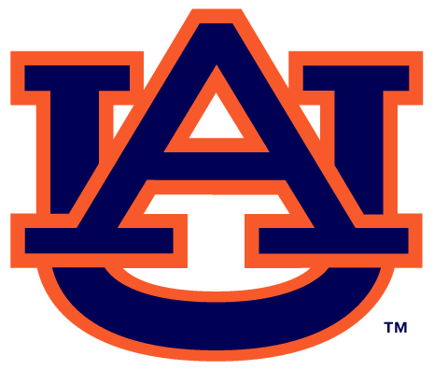


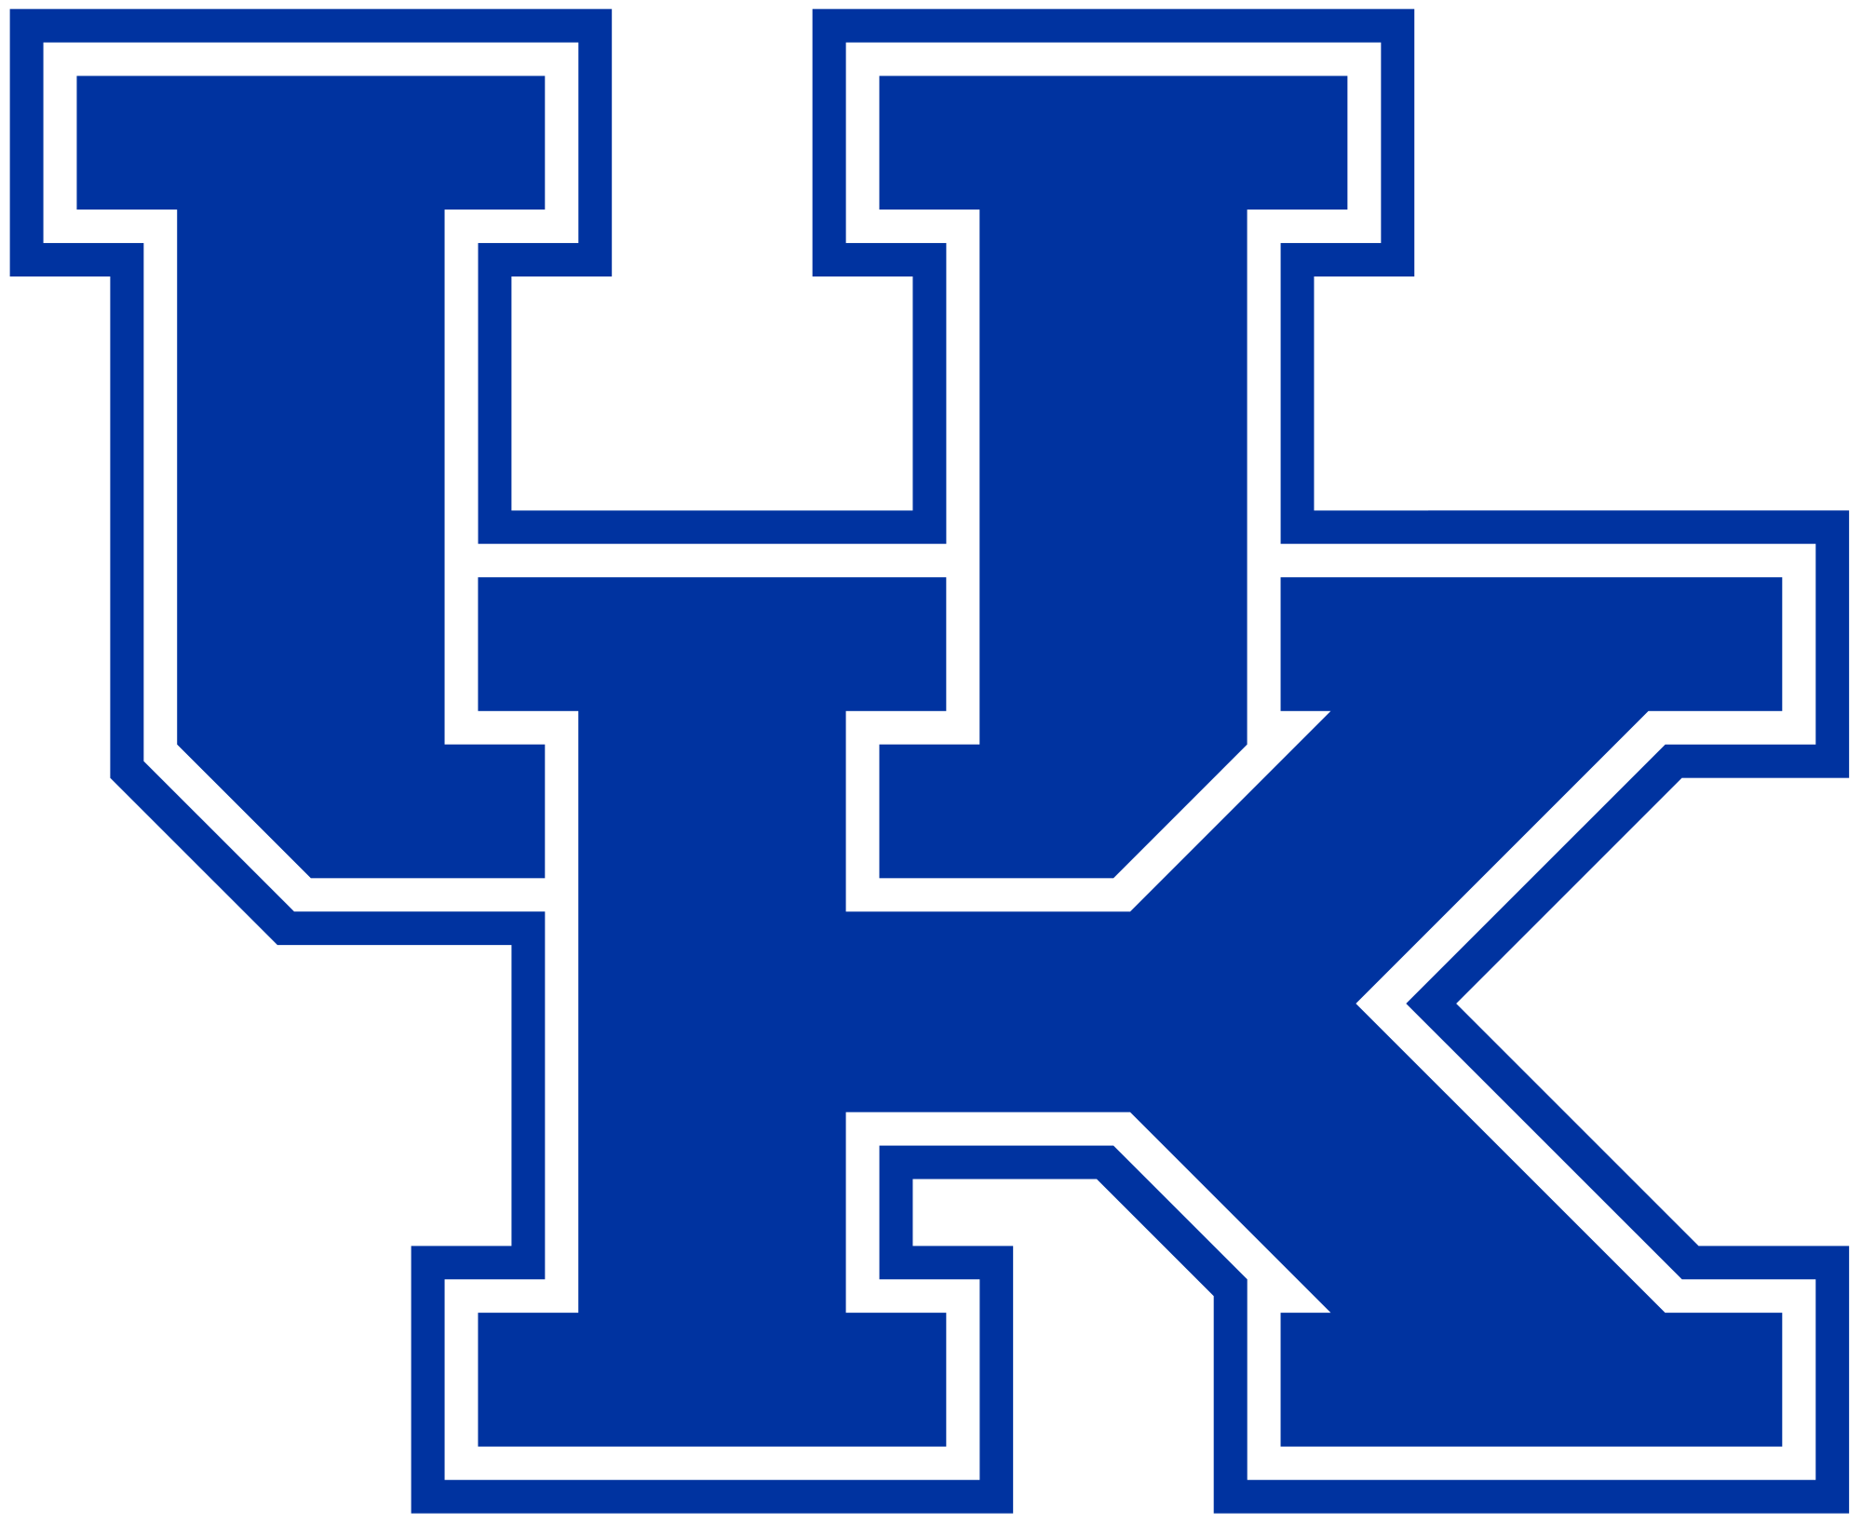






______________________________________________________
Executive Summary
Overview
This report describes a proposal to the National Collegiate Athletic
Association in which Division I college football players receive
financial aid for necessities. Universities distribute scholarships to
college football programs every year, which when given out to
high school players across the country, cover their tuition costs
during enrollment. While these costs are usually covered, many
players still need financial aid to cover their “necessity costs”. Many are unaware that the players are heavily struggling during the season, and just as much in the off-season. There are ways to end these existing struggles, however the NCAA has not created a system to end them, and has even created rules preventing outsiders from helping the players out. Fortunately, this report suggests a reasonable solution to the important issue.

There are three sections of this report which illustrate the problems, analyze the organization at fault, and provide a thorough solution:
- How the Players Live: The unhealthy and demanding lifestyle of DI football players
- How the NCAA Rules: The attitude and actions of the organization set up to protect and help players
- A Call for Change: The proposed solution benefiting the players greatly and saving face for the NCAA
How the Players Live
It is fairly easy to determine that Division I college football players have an unhealthy and demanding lifestyle. Many college football players have tuition costs paid for, but are lacking funds to pay their “necessity costs”. These necessities include food, clothing, and living spaces, and even though tuition isn’t coming out of their family’s pocket, many are still left without money for these needs. Several athletes have described their struggles such as not having enough food every day, clothes for different circumstances, and living spaces. These players would ideally head towards employment to relieve themselves of their struggles. Unfortunately, the players do not have time to work, due to the excessive hours working at their sport the whole year.
How the NCAA Rules
With thousands of college football players struggling financially to pay for their necessities, the NCAA has chosen to rule against them. The organization has created rules forbidding players from receiving financial aid and even earning money from businesses. The NCAA rulebook contains rules enforcing these restrictions, and many scandals have arisen penalizing college football players for violating them. Furthermore, the football players are mistreated and abused by the NCAA and the universities. Current and former college players have been outspoken about not having enough time to focus on their education. The universities at fault are also known to not pay for injury costs, not provide programs helping players get by, not help players find employment with their limited resumes, and overall prioritize athletics over academics. It may appear the universities are to blame for the mistreatment, but the governing body in the NCAA does nothing to stop it.
A Call for Change
With players struggling managing their lifestyle and the NCAA having a self-oriented attitude in the way they operate, there must be a change to benefit the players. The NCAA should give necessary financial aid to the players by removing their restrictions and allocating pieces of their massive revenue streams. The players should also be protected from their universities taking advantage of them, and given more time for school.
______________________________________________________
- Introduction
This report describes a proposal to the National Collegiate Athletic
Association in which Division I college football players receive
financial aid for necessities. Players suffer through an unhealthy and
demanding lifestyle, while the NCAA enforces restrictions and does
not stop the universities from taking advantage of them. A change
must be made so the players receive financial aid and are protected,
through the NCAA’s massive revenue stream and a more governing
approach over universities and football programs.

Being a DI Football Player
Division I college football players have a challenging life to manage, dealing with activities such as classes, practices, schoolwork, football games, studying, meetings, training, and more. For many, it’s all too much to handle, and understandably most have their first priority being athletics. Being that many others like myself are not DI football players, we do not personally and physically understand the lifestyle of being a DI football player full-time.

This report gives insight to what being a DI football player can be like through several components:
- Surveys of current players providing information about their time spent on athletics
- Testimonies of current players describing their struggles and opinions
- Experiences of former college football players struggling during their careers

National Collegiate Athletics Association (NCAA)
The NCAA is a “non-profit organization” that was set up to regulate collegiate athletic programs. These programs today accommodate for 450,000 student-athletes competing each year. The organization has several rules for regulating the college sports industry, and restrictions on universities and their student-athletes. For DI football players, this means they will not receive much-needed help from the organization set-up to protect them.

This report goes into detail about the NCAA’s rules and effects in different ways:
- The publications of the NCAA’s rules prohibiting football players from receiving financial aid and gifts
- The NCAA’s reasons behind their rules through the concept of “amateurism”
- Scandals that have occurred due to violations of the NCAA’s rules

The NCAA is also the governing body over the individual universities and their football programs. While the student-athletes are struggling, the NCAA focuses on regulating the industry. The universities (while focused on a variety of things) focus on the success professionally and financially of their sports programs, and do not help out the student-athletes in need. With universities prioritizing the programs over the athletes, and the NCAA being the governing body set up to regulate sports and protect the players, many believe it is the NCAA to blame for their continuous struggles.

This report shows how the NCAA and universities act and are portrayed in the players’ minds by:
- Giving examples of universities not protecting and guiding their players
- Introducing articles stating the NCAA’s and universities’ approach to college football programs
- Illustrating the current and former players’ perspectives of the NCAA

The Process for Rule Changes
This report will make it clear that several football players are in need of help, and believe the NCAA can and should help them. It is difficult for university officials and members of the NCAA to sympathize with the current football players struggling, so rule changes are unlikely. Therefore, for rule changes to occur, and for players’ needs to be met, current players will likely have to work with former players to implement a change. The players united could work together to revolt against the NCAA, but if the organization wants to solve the problem peacefully without damaging their image, they could implement rule changes themselves.

This report explains two possible processes for rule changes and the benefits of the proposed solution through:
- A scenario in which the NCAA implements rule changes helping current football players
- A scenario in which current and former players unite to revolt against the NCAA and ruin the college sports industry, with a three-step process
- The benefits of rule changes for the players and the NCAA, with regards to financial aid being distributed to college football players

______________________________________________________
- How the Players Live

Students and Student-Athletes
Being a college student can be challenging. There’s a lot of time
being spent in classrooms, doing homework, studying, and planning
a stable future. The goal for many college students is receiving a
valuable education, learning vital information about their interests,
building an extensive and impressive resume, and eventually working a job in their desired field. College students focus on academics first so they are set up for a future in which they have stable income and a lifestyle that meets their wants and needs. Apart from school many also try to have a pleasant social experience, to which they learn new things about the world and make strong relationships and connections (all while having a little fun too). Nearly all students are also involved in extracurriculars, and need time for personal activities, time to unwind from their busy schedules, and have to learn to live on their own.

Trying to balance the school and social lives is tricky, because of busy schedules and students trying to excel in both areas. Most are able to get by just fine, and enjoy the college experience without too much struggle. However, there are students that do have a much more difficult time getting by, because apart from being full-time students, these particular students are also full-time athletes. Among all students, student-athletes struggle the most, trying to manage their school and social lives, as well as managing their playing careers. There isn’t enough time to go around for student-athletes to excel in every area, leaving most of them struggling with their schedules and trying to balance. The most difficult student-athlete life, happens in Division I, where academics are viewed as just as much important as athletics, if not more, in the student’s mind (and the minds inside their program too).

Apart from DI student-athletes being much busier than regular students, there’s another difference that has gained some national attention. This popular difference deals with tuition costs, because nearly all DI student-athletes are on athletic scholarships for their universities’ programs. These scholarships cover all tuition costs, and has caused some outrage to many people. These individuals around the country are not pleased with extraordinary athletes getting to go to a university “for free”. It makes sense to most that in a place designed for education, the ones that work the hardest and are the smartest students should have their tuition costs covered, and NOT the ones with extraordinary athletic talent. To be fair, those same students have academic scholarships that cover anywhere from a portion to sometimes all tuition costs. When the DI student-athletes don’t send in checks paying for tuition, it doesn’t sit well with those who pay for pieces of it themselves (some have “free education” for academics and still aren’t satisfied with this system!). The key thing to remember is, are these student-athletes actually attending universities for free?

Necessity Costs
While tuition is paid for DI student-athletes, there are still costs commonly referred to as “room-and-board”. For this report however, we will refer to them as “necessity costs”, because living expenses and a meal plan just don’t cut it. Everyone knows that there are other costs that need to be covered apart from paying for tuition, a meal plan, and housing when it comes to paying for life at college. An online college advisor, COLLEGEdata, determines that these expenses cost anywhere from $10,000-$20,000. It may not be a problem to pay for students coming from families of upper or middle classes, who have been financially planning to pay for their child’s schooling. This schooling would of course be available through academics, because no athletic scholarship is guaranteed or should be relied upon by a family for their child. However, it may be a problem for DI student-athletes coming from lower class families, who are relieved to have tuition costs paid for, but still struggle with necessity costs.

An important thing to remember here is that there are financial aid and grants for students with excellent resumes and academics available, to help pay for their necessity costs. However, most student-athletes having their tuition costs covered, do not have access to the same financial aid and grants. Therefore, several of them struggle paying for necessity costs. Among Division I student-athletes, football players struggle the most because many come from low-income households and lower-class families. Because of this fact, it can be concluded that DI football players have the most difficulty paying for necessity costs.

Some notable professional players with rough upbringings and overcoming poverty include the following:
- Dez Bryant
- Tyrann Mathieu
- Knowshon Moreno

“You’d be lucky if you had a Hot Pocket for dinner. We used to eat at Salvation Army on the regular, when the neighbors couldn’t help us out.” – Dez Bryant
Dez Bryant

Before becoming one of the best wide receivers in the NFL, Bryant had an upbringing that most would not be able to handle. He was born to a 14-year old mother who later served an 18-month prison sentence. He had no father in his life, and bounced from home to home. His motivation to playing football was to escape his upbringing and build a much more stable life for himself. By working at his craft, he was able to attend Oklahoma State University on an athletic scholarship.

“Dez Bryant had the worst I had ever seen of a background.”

-Former NFL scout
Bryan Broadus

Tyrann Mathieu

Today, Mathieu is one of the best safeties in the NFL. He has neither of his biological parents in his life, due to his father being in and out of prison for being a murderer, and his mother abandoning him. He was fortunate to move in with his aunt and uncle after an adoption process. He had to overcome tough adversity, live without his true parents and basically no role models, and also without much financial support. Mathieu was motivated to play sports to overcome his upbringing, and landed a football scholarship at LSU.

“It teaches you to fight for everything. Nothing is going to be given to you. With that being said, you try to take that to the field. You don’t want to take any play off and not take any opponent lightly.”
“I’m a warrior. I’ve lived through a lot – and it couldn’t kill me.”

-Tyrann Mathieu on living without most of his family members growing up

“He reflects back on those tough times and he appreciates that. It was those tough times that helped him understand, nothing is given to you.”
-Georgia football coach
Knowshon Moreno

Before becoming one of the most versatile running backs in the NFL, Moreno had to cope with a troubling childhood. He grew up without a mother, and lived with his father in a series of homeless shelters. It was tough for him growing up in New York City without stability at such a young age. Luckily, his grandmother was able to provide a stable living environment and the opportunity to play sports to succeed. Moreno looked to football, capitalizing on his natural athletic ability and drive.

“You’ve got to be a tough-minded individual. What’s very gratifying is to watch people grow up, not just in their football life but in their off-the-field life.”
-Broncos coach John Fox

Of course, these athletes’ upbringings are rare circumstances, because normally players of poor backgrounds do not have a troubling lifestyle to their extents. However, there are college football players recently who struggle once they make it to a university, due to low funds available for necessity costs.

Players Living Without Necessities
There are numerous examples of football players living without basic necessities such as food, clothing, and living spaces, simply because they struggle financially. It’s a major problem being caused by players not having enough money due to their family backgrounds, and by the NCAA not allocating funds providing financial aid relieving them of their struggles. It’s a major issue for the players, who are student-athletes trying to succeed in both their academics and athletics. The players should not be struggling to get by, and in not-that-perfect of a world have necessities to do so. As said, many players recently have not had these necessities available, and therefore struggle to live as players (when they’re in reality students!).

Food

UConn basketball star Shabazz Napier made national headlines back in 2014 when he said he went to bed “starving” because he did not have any money for food. There were no programs set up by the universities and the NCAA providing funds for food, with the exception of one minimal scholarship check. Napier’s comments got the nation wondering about the struggles of college athletes, and stirred the conversation as to whether the NCAA should act to help them with food necessities or not. It angered a lot of athletic directors and the NCAA, with a star player having no money for basic necessities such as food. Although, it encouraged players at other universities, and those without lots of funds, to speak up, and football players took the opportunity right away.

The conversation reached the University of Ole Miss, where quarterback Bo Wallace had a first-hand account to players’ struggling paying for food and not having necessary food available to get by. Wallace agreed with Napiers’ comments, and felt it was necessary to speak up on behalf of his teammates and DI football players around the country. That ‘one minimal scholarship check’ accounts for $1,000 to which Wallace says, “barely gets players through the month” and that “they need more”.

“A lot of guys go to bed hungry at night…that’s real. We have our breakfast and lunch. Our café is open, so you can go and swipe your card, but dinner you have to pay for it…We need more compensation for that just to be able to survive.

If I didn’t have my parents, I don’t know what I would do. A lot of these kids don’t have the same things that I have.
I know that their struggle is something terrible.”

-Ole Miss’ Bo Wallace to CBSSports (7/17/14)

It’s obvious that these extraordinary Division I football players, especially those playing in major conferences like the SEC, should be well-fed. Bo Wallace is fortunate to have his parents to rely on for his food costs, but it’s evident the problem is affecting him. He refers to him and his teammates needing more compensation to survive, and he speaks up for his struggling teammates.

Not many players have the ability to speak up freely about ongoing issues with their football programs and the NCAA. So, many Ole Miss football players are thankful for their quarterback stepping up and making headlines about their struggles. Wallace was brave enough to make such comments, and it definitely made an impact. The story continued to get national attention and spread through the world of college football too, making it harder for the NCAA to deny necessary compensation for food to the athletes.

However, a change has still yet to be made.

Clothing

Food is definitely not the only necessity missing for the football players, and other compensations should be allocating to them. Wallace was also outspoken about another issue: players not having money for necessary clothes. The DI football players don’t have a problem finding clothes to put on their backs, and buying luxurious clothes isn’t a necessity for everyday life. Although, the players find themselves spending lots of money on dress clothes for events and media days. The football players cannot wear sweatshirts and sweatpants to important events, as that will negatively portray their university and football program. Such clothes are not given out like uniforms, so the players must pay out of pocket for the pricy clothing.

Wallace was not just a “hungry” football player speaking up for him and his teammates’ health. He also spoke up about his teammates not having money for these clothes, which was also an admirable thing to do considering he didn’t share the same problem as his teammates. Wallace said, “I wonder how players with minimal resources pay for the suits and ties they must wear to media days. A lot of guys don’t have the money to go pay for it. Schools can tap into a special assistance fund to help cover player expenses for special events, but it leaves out clothing expenses.” He’s not the only one who has dealt with this issue.

Dominic Sylvester played offensive line for the University of Alabama at Birmingham back in 2014. He received media attention for being outspoken about needing compensation for things such as clothing, travel expenses, and a little more. Like the suits and ties bought by Ole Miss football players, Sylvester finds himself spending big money on dress clothing, more specifically dress shoes. He wears dress shoes to church and for team events, and tries to preserve them (being his only pair) the best he can, because he does not have money to buy new ones. “A good pair of shoes for me, which are hard to find because of my size, can cost $150. You make them last and last. I don’t have a lot of extra money to buy new ones.”

Sylvester’s athletic scholarship covers tuition, books, dorm, and meal plan, but now “miscellaneous expenses” like new shoes and clothing. He says there is a gap between what the athletic scholarship provides and what the actual cost of attendance at college usually demands. At UAB, he says the gap is close to $3,000. Wallace also said the cost of attendance would be a good way to determine how much money is needed, for necessity costs such as food and dress clothing. Along with Wallace, Sylvester believes there should be compensation allocated to football players without necessities such as food and clothing.

“I’m all for compensation because we could absolutely use the money. Being out of state, I had about $1,100 in travel expenses last year. The Pell Grant doesn’t full cover our miscellaneous costs such as a new pair of shoes, a suit for special occasions or travel expenses.”

-UAB’s Dominic Sylvester (1/18/14)

The Pell Grant is a need-based grant, provided by the federal government. Sylvester receives $4,500 a year, but there still needs to be more money available he says for miscellaneous costs. Since Sylvester does not want to put his family in anymore financial stress, he believes the NCAA should step in and provide more money for necessities he is living without. The financial struggles can be relieved of easily if the NCAA were to step in to help the DI football players, who are paying out of pocket for dress clothes, and stressing the pricy expenses.

Living Spaces

Can you imagine DI football players not having money for living spaces? Yes, nearly DI football players have room and board covered when it comes to having scholarships. However, some just have their education fees taken away, and those players are left having to pay for living spaces. It is troubling to picture a DI football player not having a place to stay all of the time, yet it happens. Food should be the first priority when it comes to families paying for their player’s necessities, and in most cases, it is because of a means for survival. Second would be clothing expenses (if possible!) because they are required for the football program’s events. The final necessity, living spaces, would fall last, because some players are able to room together or live at home. It doesn’t always work out like it is supposed to, and many players are left without living spaces, and compensation to cover their living costs (which could fall under miscellaneous).

USC defensive lineman Stevie Tu’ikolovatu was one of the players who could not afford a living space. He left the University of Utah to come play at USC, and had no place to live due to his transfer, which prevented him from having compensation for a living space. Tu’ikolovatu had no place to live for months, and was so serious about his football career at USC, that he wasn’t giving up. He decided to fight through his difficult circumstances, and was forced to live out of his 2004 Chevrolet Suburban. Not having a place to stay on campus like his fellow teammates and other college students, he considered himself to be “homeless”.
“I guess you could say I am pretty much homeless. It’s pretty uncomfortable because my body isn’t adjusted to sleeping in a car, and I’m also 320-pounds. That body does not agree with the back of an SUV, and it made my football life a lot harder. I’m determined to not give up. Playing football is everything to me, and even though I’m struggling now, I know people have a lot worse, so I try to be grateful.”

-USC’s Stevie Tu’ikolovatu to LA Times (4/22/16)

Football Players’ Schedules
The most obvious solution to pay for necessities without compensation, is for players to get employment. But for student-athletes playing sports full-time in Division I, it’s a lot easier said then done. In fact, football players spend the most time working at their sport during what are commonly referred to as “athletic hours”.

These hours include a variety activities such as
- Practices – where players work with their team in order to succeed on the field
- Meetings – where players study their opponents, learn from their previous mistakes, and communicate game plans
- Training – where players exercise and train to become more athletic on the football field
- Games – where all of the hard work pays off, and players compete representing their program

A study was done by the NCAA in 2011 surveying all 450,000 collegiate student-athletes about their playing careers at the university. Many questions were asked regarding a number of topics such as academics, well-being, their playing careers, and so on. One question that gained national attention, and is still being discussed today, is how many hours each athlete works during the week at their sport.

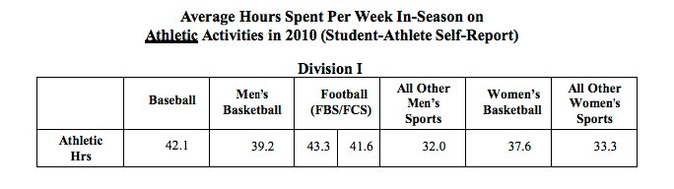
Table 2.1 – Courtesy of Business Insider (2016)

Table 2.1 shows that Division I football players spend 43.3 hours a week during the playing season on athletic activities. These are the same activities above (practices, meetings, training, games) that qualify as “athletic hours”. A football player’s schedule can only handle so much when it tries to balance academics and athletics. This survey proved the suspicion to be true that many football players priotize athletics over academics due to their extensive schedules working at their sport.

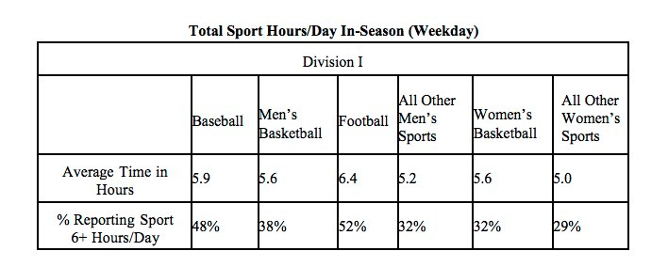
Table 2.2 – Courtesy of Business Insider (2016)

Table 2.2 shows that Division I football players spend 6.4 hours each weekday during the season on athletic activities, and that 52% reported spending over 6 hours a day on those activities. Putting it into a better prescriptive, it is clearer to see how much time each day is devoted to football programs. It may make more sense to those who see athletics as being prioritized more by the players, because they clearly spend more of their time on football than school.

With all of the time being spent on athletic hours, do players have any time for employment during the competitive season for football?

Competitive Season
In reality, the players do not have time for employment during the competitive season. If they did, there would be no conversation about players needing financial aid from the NCAA. Players would be able to work and cover basic costs such as clothing, and probably some extra meals. It would not solve the problem in its entirity, because players cannot find part-time employment paying $10,000-$20,000 a year. Football players getting jobs is the most popular and quite frankly the first suggestion when it comes to players needing more money. When the players hear this from the media and other student-athletes, their immediate thought is that they simply do not have any time to work during the competitive season. And looking at the results of the NCAA’s survey back in 2011, it is clear that athletic hours clear up any free time for part-time employment.

In the same article to which published Dominic Sylvester’s thoughts about players getting compensation from the NCAA, another player’s thoughts on the matter were brought to attention. Chris Conley, a wide receiver at the Universtiy of Georgia, was outspoken about players not having time for jobs. He is not only a star football player at his university, but also the student-athlete advisory reprensentative to the NCAA for the Southeastern Conference. This is a pretty important position, because the SEC is not only the top conference in college football, but also because he represents hundreds of players (thousands of student-athletes across the conference and multiple sports), and communicates their inqueries to the NCAA. Playing for a top program at Georgia, Conley knows first-hand that there is no time at all for jobs.

“When a coach is concerned about job security and a school wants to win a championship, and if it is a large-revenue sport, you are pushed to put more time into the athletic side of things, and it doesn’t shorten the amount of time you have to spend on school. You are putting extra hours in the film room, extra hours in the weight room,
extra hours getting treatment.”

-Georgia’s Chris Conley (1/18/14)

Conley says that his program, that is actively trying to win a championship like most other programs, pushes players to put in more time into the athletic side. While the players spend more hours than most would on athletics, the players’ time needed to focus on academics remians the same. After all of that, there is no time for part-time employment.

“You end up doing all those things, and you get back to your room at such a late time, you need to study. There is no time for a job.” – Chris Conley

Being the SEC’s advisory for student-athletes (including DI football players), Conley knows for certain both through his personal experience first-hand, and the accounts of players he follows, that there is “no time for a job”. With all SEC players and student-athletes being focused on championships and also prioritizing academics (as they should), it is evident that they cannot work to relieve themselves of financial struggles. Many conferences are just like the SEC, where programs are pushing athletes to succeed and win championships (as Conley says relates to the coach’s desire for job security and university revenue). Student-athletes throughout Division I are pushed into a schedule full of academics and extensive athletic hours, where there isn’t any time for employment. And no players know that to be true, more than the football players.

Off-Season
If players are too busy during the competitive season, it could be said they should work during the off-season to earn some financial aid for necessities. The same Division I footbal players who do not have time for employment will tell you that there aren’t much differences when it comes to the football programs’ competitive and off-seasons. The main differences throughout all DI football is that games are not being played during the competitive season, and all other athletic activities require more hours. Games aren’t being played on Saturdays for months, however practices, meetings, and training take up all that extra time, and more…

An article was published by Inside Higher Ed back in 2015 with the headline, “What Off-Season?”, referring to players have trouble with the term suggesting there is a season where they are “off” from their sport. The article features an important introductory statement in which it portrays players’ thoughts on “off-seasons”.

“Most college athletes say they spend as much or more time on sports during the off-season as they do during the season, leaving them little time for common college student actvities like studying, internships, and part-time jobs.” – Jake New
In that same year, there was a panel organized by another top conference, the Big 12, in which four college athletes are asked about reformations to improve college athletics. Some of the proposals such as less prime-time games and less traveling for games were shot down by the athletes. However, they was a common issue that all of the athletes believed needed reformation: the amount of time they spend on sports during the off-season. The athletes were heard complaining about training all-week during the spring when their sport plays games in the fall, and how it takes much needed time away to refocus on schoolwork.

Juggling athletics and course work during the season is very difficult, so the off-season would be a time to excel and shift the balance. However, the athletes felt just as overworked in the off-season. The NCAA agrees, because a 2010 survey of all DI student-athletes found interesting data on how athletes spend their time in the off-season compared to their competitive season.

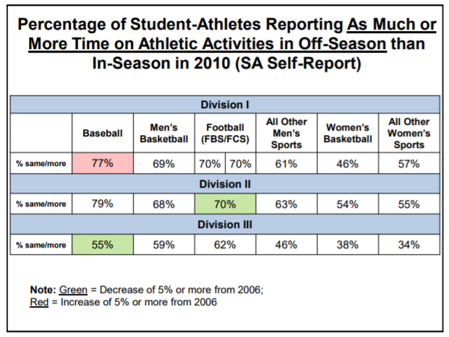

Table 2.3 – Courtesy of NCAA (2010)

In Division I, it was found that 70% of Division I football players spend as much OR MORE time on athletic activities in the off-season than the “in-season” (competitive season). It’s a very surprisingly statistic, because most believe players have more time in the off-season and should work part-time employment to pay for necessities. The data also proves that the issue is common across multiple sports and even genders. Nearly all major DI sports require the same, if not more, time for athletic activities in the off-season.

The article says that the NCAA already has rules for how much time athletes can spend on athletic activities, especially in the off-season, but it is widely assumed most coaches find ways around them. In fact, a handful of progarms have been penalized by the NCAA in recent years for conducting “athletically related actitivities” out of season extensively. The people that know this to be true, apart from the players and coaches themselves, are the professors, who believe players should have more time for academics in the spring due to the competitive season in the fall. Unfortunately, the truth is that players spend the same amount of time, and it doesn’t sit well with some professors.

“Out-of-season activities being known as voluntary is a common practice at universities. Voluntary activities are described by the NCAA as being initiated by athletes and having no coach present, but that is rarely ever true.

There’s technically an off-season, but there are these voluntary workouts that most coaches say are voulntary but then expect athletes to be at.

The system is set up to where the coaches encourage athletes to train all year round. They are pushed in a competitive sport to have “voluntary” practices and training activities.”

-South Carolina’s Professor Mark Nagel
to Inside Higher Ed (5/8/15)

Nagel has taught several student-athletes in his sports management classes at the University of South Carolina. He says that the pressure for students to prioritize athletics and “voluntary” activities over academics is most prevalent in the big-revenue sport of college football. Another professor at the University of New Haven, Allen Sack, says that the efforts to reform off-season activities start with putting more focus into the coaches. He believes the coaches are causing all of the pressure in the off-season and need to be restrained from implementing it.

“The focus should be in getting coaches under control. The demands they make are absurd. Workouts and practice go on year-round. The coaches must be forced to realized that college athletes are not professionals like those in the NFL.” – Allen Sack

It is a very reasonable claim, that the coaches should take pressure off for the football players in the off-season. If the coaches made the reform, players would have more time to focus on academics, and especially have more time for employment. Regular college students use the “off-season” summer to work full-time employment, and do not fall under much financial stress paying for necessities during the school academic season. If football players could use this time too in their own off-season to find employment and earn money, the financial stress problem will take care of itself.

Summary
In summary, the DI football players are under financial stress, and cannot pay for necessities.The players live without necessities such as food, clothing, and living spaces, and need financial aid in order to get by as student-athletes. Most suggest to the players that they find employment to relieve them of their financial stress. Unfortunately, the players do not have time at all during the competitive season to work due to their extensive schedules, devoting more hours on athletic activities than academics. The off-season isn’t a solution either, due to players being just as overworked as their competitive season. There must be outside help.
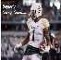
______________________________________________________
- How the NCAA Rules

Operations
The National Collegiate Athletic Association as said before is the
organization set up to regulate collegiate athletic programs. The
programs accommodate for 450,000 student-athletes, whose
sports are organized each year with events, championships,
conferences, games, and more. The NCAA is a “non-profit” organization that brings in over a billion dollars in total revenue annually. The organization says those revenue dollars cover their costs and go back to the universities they govern over to keep improving their programs. Though, most call into question what the NCAA does with most of their millions in revenue, when there is money the universities do not necessarily need.

The NCAA is in charge of regulating college sports, and it is a large task with thousands of programs and hundreds of thousands of athletes needing a structured collegiate athletic experience. In order to maintain control over the universities and the student-athletes they bring in, there has to be many rules prohibiting certain actions from taking place. In the billion-dollar industry that is college sports today, it can be challenging to solve every issue, and sometimes not everyone wins. The NCAA regulating the entire industry has to worry about themselves staying on top and making sure they are able to keep the industry alive. The universities need to be happy and benefiting from the college sports world, or else the industry fails, giving the NCAA no purpose. The athletic directors and coaches need to be treated apporpriately, so the programs are able to be run successfully, and millions in revenue can be earned to go around for everyone. And lastly, the players need to be taking care of to an extent, so the programs can run and players have a stable athletic experience in college. Scholarships, hirings, revenue streams, television deals, it all is kept alive by the NCAA regulating the college sports industry.

The ones making college sports what it is today, the extraordinary athletes showcasing their talents and competiting across the country, are taken care of…to an extent. They are given athletic scholarships, where they can earn a valuable education with no tuition costs. They are given excellent programs where their talents will turn them into stars and provide better opportunities to become oustanding players and potentially moving on to the professional leagues. They are given platforms to become better individuals both on and off the athletic playing field, and excel in their athletic and academic careers. However, they are still in need of some things in order to achieve.

The student-athletes understand that playing sports full-time at the DI collegiate level will take away most of their free time to either enjoy college or more importantly focus on schoolwork. They know the danger and responsibilities that go into being a DI athlete, and the NCAA has a lot of rules in place to help them. Although, the student-athletes need more from the NCAA. While it is clearly a problem that the athletes spend too much time on athletics all-year round, and do not have time to take advantage of their “free education”, the NCAA looks the other way, and it is frustrating for them to deal with. While it is also a problem that athletes cannot fix their issues and relieve themselves of problems, the NCAA also looks away. When it comes to the most important issue facing college athletes today, is is that they do not have necessary compensation given to them in order to get by. They need their necessity costs covered by the governing organization that already gives a lot to them. It is needed however, but the NCAA decides to rule against them with restrictions.

Rules and Restrictions
The NCAA limits the student-athletes from receiving any financial aid. With more of a focus for the purposes of this report on DI football players, they are the ones who have been the most outspoken on this important issue, and are the ones in most need of financial aid for necessity costs. It would make sense for the governing organization running college sports in the NCAA to make sure everyone is taken care of to the maximum capacity, so nobody inside the industry is struggling severly to get by. Unfortunately, the people at the bottom running the whole show in the DI football players, are in desperate need of help. The players as we’ve previously seen have been outspoken to the media about their problems, calling into question the rules of the NCAA. The limitations are causing financial and emotional stress on the players, who are already struggling with many other factors to begin with. They want to be relieved of their financial problems, and receive necessary aid. It isn’t very simple due to the NCAA’s rules prohibiting any type of financial aid for the players.

So what exactly are the rules restricting the players?

On the NCAA’s website, and in the yearly NCAA College Football Rulebooks, it states that the players cannot earn money or receive outside financial aid. Players cannot be compensated for participating in collegiate athletics, and may be declared inelligble for receiving any financial aid that isn’t earned through federal and university programs. Most of that financial aid comes from outside invidiuals, and we will look at what happens when players violate these rules. A lot of the rules and restrictions fall under the NCAA’s concept of

AMATEURISM

According to the NCAA, “amateurism” is competition that is the bedrock principle of college athletics and the NCAA. Maintaing amateurism is the critical component to preserving an academic environment in which student-athletes are prioritize a quality education first. The NCAA’s model for collegiate sports has players being students first and athletes second, even though all Divison I athletes believe it is unfortunately the other way around. The amateurism concept was adopted by the NCAA in order to provide a quality educational experience and an equal competiting environment for all athletes.

Amateurism prohibits the following for all incoming Division I athletes, and most specifically football players:

- Contracts with professional teams
- Salary for participating in athletics
- Prize money above actual and necessary expenses
- Play with professionals
- Tryouts, practice or competition with a professional team
- Benefits from an agent or prospective agent
- Agreement to be represented by an agent
- Delayed initial full-time collegiate enrollment to participate in organized sports competition

A lot of those restrictions are very reasonable, because student-athletes should be focused on collegiate athletics while they are still competing, and not have their attention on the professional life. Nearly all
Division I football players are okay devoting most of their time to their collegiate programs to which they enrolled. After all, there is a 1.5% chance that college football players actually make it to the NFL, and it would not make much sense for them to focus on the professionals as opposed to their university anyway. The university is what provides them with an education that is needed for many, and the scholarship is what keeps them around. With players not being able to receive compensation for playing, and players not receiving any financial aid from the NCAA, their financial struggles remain. It leaves many without the necessities to get by, and causes football players’ academic and athletic lives to be damaged. Players are definitely in need of some financial aid, but the NCAA restricts any sort of compensatory action from taking place. Apart from the tuiton fees being waived through scholarships, and any federal or university grants, the players are left on their own to cover their necessity costs. Amateurism is the reason players are forced into being restricted student-athletes, even though the players disagree entirely with how the NCAA sees them being portrayed. The players see themselves as overworked, undercompensated, and struggling to get by.

With the NCAA ruling against the players, many in recent years have decided to take a stand, by taking matters into their own hands. Below will illustrate how several DI players were involved in scandals that hurt the reputation of themselves, the universities, and the NCAA. It would all go away with the NCAA compensating their players for necessity costs. A hands-on approach to the individuals they represent will benefit all.

Scandals
If players are gonna fight the NCAA and revolt against their restrictions, they aren’t going to do it in a small manner. Most players who take money from outsiders are not looking to cover their necessity costs. They are trying to earn a kind of “salary” for all of their success in the college football world. A number of scandals have occurred due to players violating NCAA rules, and it can be said that the media exploits these star players for doing so. It can also be said that there may be scandals to which the NCAA has no idea about, because the ones that get the most attention are star players receiving thousands of dollars in compensation.

The “pay-for-play” scandals have rocked college sports and definitely college football in the past decade through numerous occassions. Though the players’ actions are not directly relating to the purpose of attaining necessities, the scandals are important because it shows how some players disapprove of the NCAA’s amateurism viewpoint. If these scandals happen over players wanting large amounts of compensation, and are willing to risk their careers and reputation over it, can you imagine how many players might accept money to help them get by at the minimum?

Cam Newton, Auburn

In 2009, star quarterback Cam Newton was being recruited by several SEC schools to play his last collegiate season on a scholarship. However, him and his father Cecil were looking for more in order to commit to a school. It was not much about which program they preffered Cam to play in, because he had been planning to be a top NFL draft pick regardless. So the two decided to partake in a pay-for-play plan which would result in compensation, separate from a scholarship, in order to get Newton to commit and play for an SEC program.

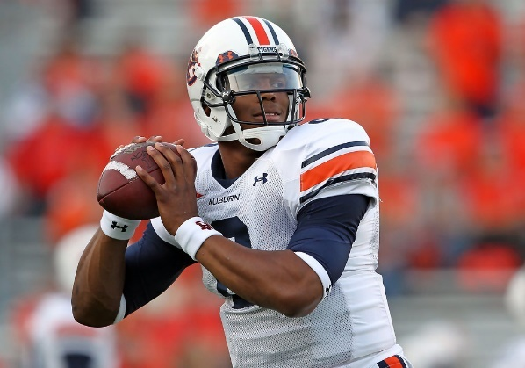
Cam was ruled ineligible by his university after the NCAA found evidence that his father asked for money to play at a school. Cecil asked for and amount in the range of $120,000-$180,000 in exchange for his son to play football for Mississippi State University. This solicitation falls under a “pay-for-play” scheme, and is a violation of amateurism under the NCAA rules. What followed was his university where he ultimately committed to, Auburn University, filing for Cam to be reinstated by the NCAA after learning that his father was the one committing the illegal activity behind his back. Cam would be reinstated, and allowed to play for the rest of his season at Auburn. Amateurism almost cost Newton his Heisman Trophy, Auburn the National Championship, and his reputation as a credible athlete.

The scheme that Cam and his father used was that if Cam had received money from Mississippi State, the Newtons would have accepted it, and Cam would take the fall. But if the word got out and Mississippi never paid, Cecil would take the fall, which is what ending up happening. The scandal was more about the Newtons trying to cash-in on their opportunity to make money, and take a stand against restricting compensation through amateurism. The NCAA did not have to punish Cam himself, but him and his program have been called “cheaters” ever since the word got out. Newton did not accept any money and played at Auburn, but could have if MSU offered it. Cam and his father obviously feel that players should be able to earn money.

Reggie Bush, USC

In 2006, reports surfaced that star running back at the University of South Carolina Reggie Bush accepted gifts from a sports agent. His family was reported to have violated NCAA policies by receiving compensation and for having connections to a sports agent. Lloyd Lake was giving $290,000 in gifts to Reggie Bush and his family in order his sign Reggie, once he was officially eligble, and become his sports agent once he was in the National Football League and playing professionally (potentially earning millions of dollars). Bush played for USC from 2004-2005, and the scandal rocked the university and college football world.

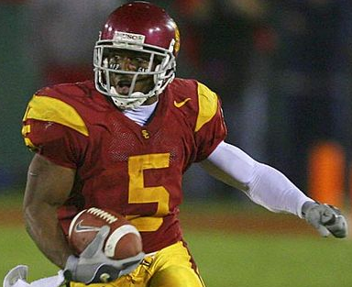

The investigation went on all the way through 2010, when the NCAA announced there would be major punishments against USC. The NCAA had to punish the university for not watching their athlete more closely, and because Bush could not be held ineligble to play football as he was in the NFL. The NCAA found that Bush received lavish gifts from the sports agent. USC was forced to vacate their last two wins of the 2004 season, including their national championship win, and all of their wins in 2005, due to Bush’s actions violating NCAA amateurism rules. The football program was also banned from bowl games for 2010 and 2011, and lost a total of 30 scholarships for recruiting over a three year period. The running backs coach, Todd McNair (who was coached Reggie Bush personally at USC), was banned from off-campus recruiting for a year after it was determined he knew of the rule violations. The NCAA after all of these punishments, decided to force another, which was for USC to permanently disassociate itself from its star player.

Being a high-profile player at the university, it was apparent to many that the program should have watched Bush more closely. NCAA infractions committee chairman Paul Dee claimed that USC shold have invested more effort in monitoring his relationships because “high-profile players merit high-profile enforcement”. Bush’s relationship with USC athletic directors, the program, and the president has been damaged permanently, due to the damage to the university’s image and punishments sanctioned on the football program. It is as if Bush never even played at USC, because the wins do not count, there are no items dedicating Bush at the university’s facilities, and Bush was forced to return his Heisman trophy. The Reggie Bush USC Scandal hurt himself and his university, because Bush wanted to earn compensation at school.

North Carolina Football Players

In 2017, it was reported that University of North Carolina football players Marvin Austin, Robert Quinn, and Greg Little accepted money from a sports agent back in 2009. Like Bush’s scandal, but to a lesser extent, these players were offered money by an agent in order to sign with them after school, when Quinn and Little played in the NFL. The agent, Terry Watson in Georgia, plead guilty to violating NCAA rules. He gave nearly $24,000 in cash, airline tickets, and hotel rooms to the football players while at UNC. Players are not allowed to accept meals, gifts, transportation, or other items at all under NCAA’s amateurism rules. There are restrictions especially for players accepting money from sports agents.

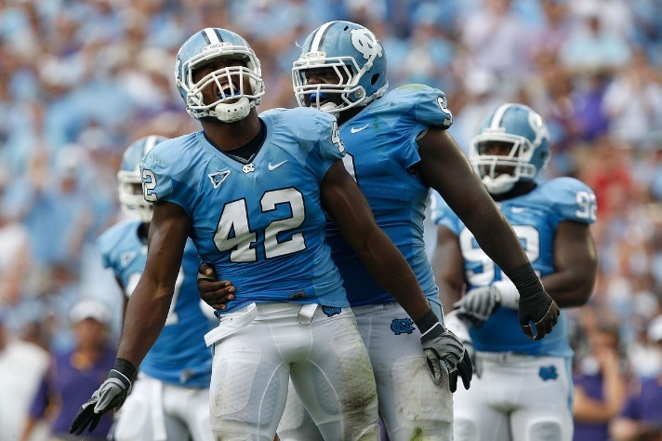

Three years later in 2012, the NCAA issued penalties against the UNC’s football program, which included probation for three years and postseason ban. The players were not allowed to play football at UNC in 2010, and the university program’s image was damaged after not watching their players more closely. It was not necessarily a “pay-for-play” scandal, even though many refer to this scandal as one today. Watson was sentenced to 30 months of probation, banned from working for a sports agency, and is not allowed to present himself to any college football players. The three players would not have accepted small amounts of cash if they had money for what they were looking for. They clearly feel they should be able to accept money for being a big-name college athlete, and the risks were worth it to them, even with the universirty being penalized.

Ohio State Football Players

In 2011, it was reported that eight Ohio State football players accepted $14,000 in cash and tattoos in exchange for jerseys, rings, and other Ohio State football memorabilia in 2009. Head coach at the time, Jim Tressel, knew about the violations but kept quiet. Had it not been kept quiet, Ohio State’s football program would not have been punished, and only the playing careers of the eight would be hurt by the NCAA. However, he kept the actions quiet, and the NCAA went after the players as well as the probgram. It was also reported later on that three players were suspended for accepting $200 from a university football booster. It was also revealed that the same booster paid players lots of undeserving wages for little work. The booster was removed from the program, and furthermore hit the university program.

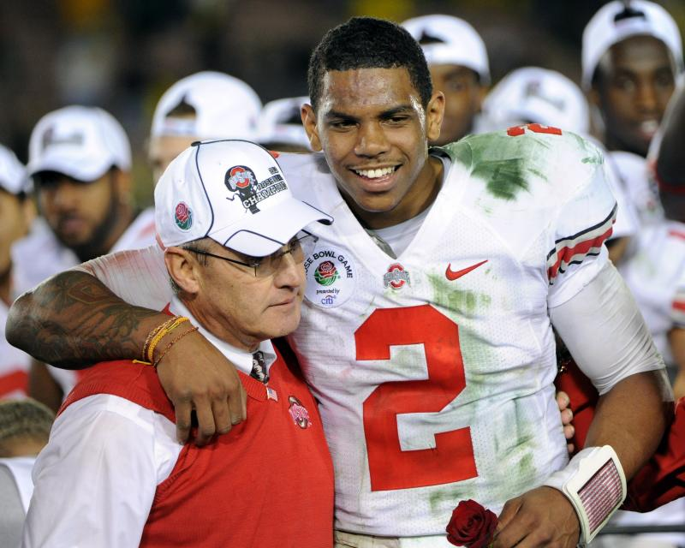

At the end of it all, the NCAA issued bowl bans and loss of scholarships to Ohio State, damaging the reputation of the university and the players. For over a dozen players involved, it was worth the risk in accepting money, because they wanted to be compensated for their hard work, and believed they should be. Amateurism claimed another university as victim to players not following NCAA rules. The scandal and punishments are just another example of players wanting compensation for their play, and being okay with the punishments.

Donald De La Haye, UCF

In 2017, UCF kicker Donald De La Haye was ruled ineligble after refusing to give in to an NCAA request. The request was for him to stop monetizing from his popular YouTube channel, which has over 90,000 subscribers and amassed nearly five million views. The NCAA took issue with the fact that videos bring in advertising revenue, and told him to stop accepting money off of his athletics-related videos if he wanted to play college football. His university suggested De La Haye continue to profit off of his channel, but not collect revenue from athletic videos. The NCAA agreed with the university’s suggestions, but he refused to non-monetize his athletic videos, and the school suspended him from the program.

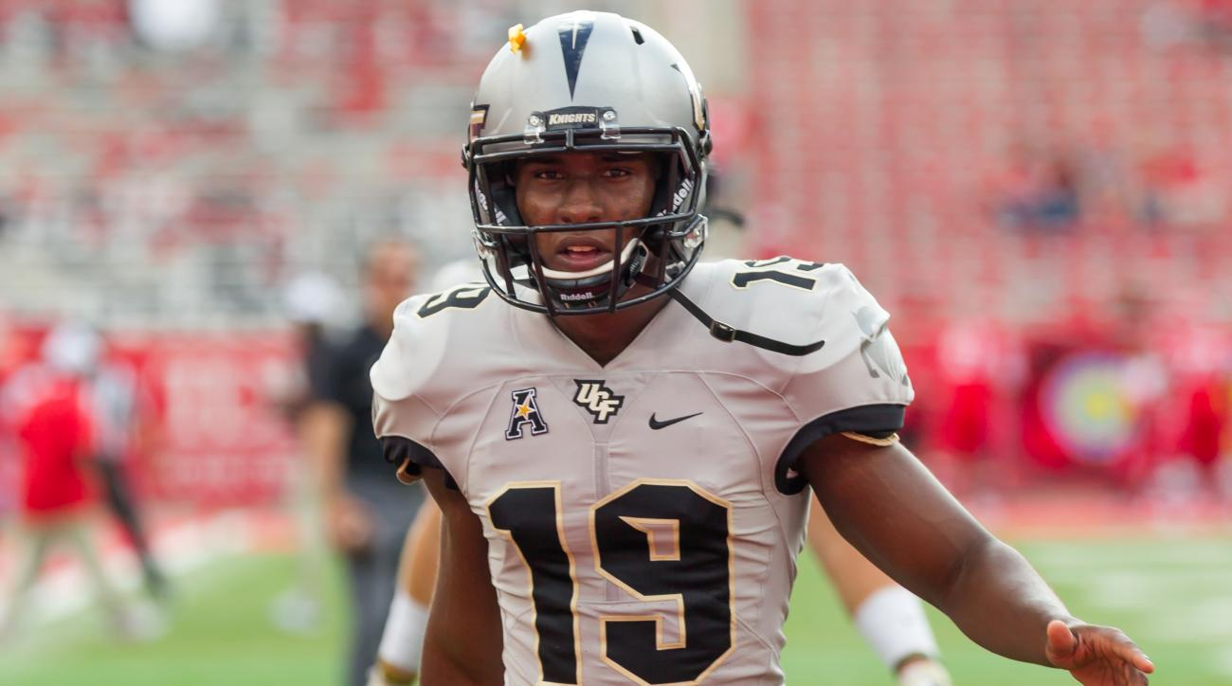

De La Haye made it clear to Sports Illustrated that he was not going to back down from his fight with the NCAA, who believe he violated his amateurism contract stating he could not earn compensation from his athletics. However, he believes he did nothing wrong, because he was monetizing off of videos and not accepting money for his play. He said “I feel like it’s about time for things to be changed. The times these rules were made weren’t really up to par with what’s going on in the real world.” It is clear De La Haye believes he should be able to be compensated for his hard work and his videos online entertaining his followers. The NCAA in his mind is not up to speed with today’s technology and ways of collecting revenue and compensation through social media. Amateurism does not specify about compensation through social media platforms and more specifically videos. De La Haye believes players should be able to be compensated from their social media, technically it being a business, and thinks there needs to be a reform to amateurism’s restrictions.

Theses scandals all connect a common theory: players deserve to be compensated for their play

Protecting the Players
It was mentioned before, and his been mentioned multiple times in the media, that the NCAA is the governing body regulating the college sports industry and university progams, and that it prioritizes academics over athletics. And as proven, the players are overworked and under financial stress, leading them to believe universities and programs prioritize athletics over academics. It has also led them to believe the NCAA is either oblivous to the programs’ continuous actions or does not care to protect the players. The NCAA wants to make the college sports industry as great as possible, and wants the individuals and organizations below them to flourish without any worries. But the players have been outspoken about financial stress, claiming they do not have enough time for academics, and having too much time allocated to athletic activities. The players are in need of help, and when the programs and universities do not listen, they look to the governing NCAA to implement change for their benefit.

If the players’ needs are not addressed, they should at least be protected from having any more harm being done. A challenge for a lot of struggling football players is that while they are so busy managing their active academic and athletic careers, they need to plan for their future. A lot of college football players, once getting DI scholarships, look to play professionally after college on into the NFL. Most won’t, as said before that only 1.5% actually do get to play. The challenge presents itself to the players whether they should focus more on academics (even with their busy schedule) or focus on athletics and try to go pro (still with their busy schedule).

The elephant in the room when it comes to preparing for a future in the NFL is whether the player is good enough to play professionally. And furthermore, what happens to the player if they get injured playing?

Injury Costs

What happens to many is that the universities DO NOT cover injury costs to players. Injury costs include surgery costs, physical therapy, and other miscellaneous medical fees. University programs are not necessarily responsible for injuries, and not held accountable for the costs. The players are left abandoned by their programs when it comes to injury costs. In comparison, in the NFL, players are able to cover their own costs, or the team files health care in every player’s contract. It’s unfortunate for players already needing necessities, and not being able to pay for them, to also have injury costs imposed on them.

They look to their programs and universities to help them out, but the universities are not required to provide healthcare when athletes get hut. It leaves many football players (a sport that results in many injuries and lots of injury costs) and their families devasted feeling abandoned by a program and univrsity that wanted them.
A famous case of a university abandoning its injured athlete was at South Carolina, where defensive lineman Stanley Doughty had a knee injury. He had a great career at the football program, until a series of knee injuries limited his playing time. The university would not pay for the injury costs so Doughty could heal and return to the field. Like the NCAA says, universities are not necessarily responsible for providing healthcare for their student-athletes, and it’s a hard fact to understand when injuries occur.

Players are getting scholarships from universities to play football and are given the opportunity to earn a valued education. The players are thinking about suceeding and maybe playing in the NFL. They are not thinking about injuries, and if they are, they are assuming the same program covering all of their tuition and room-and-board costs, will also cover their healthcare costs. Doughty was left to pay the injury costs on his own, and it even led to the downfall of his playing career.

“I put everything in their hands and trusted them. They said I would be taken care of.” – Stanley Doughty

Doughty and his familiy learned the devastating truth that the university wouldn’t help him, and it scared many college football players throughout the country, who learned their injury costs won’t be covered, and programs just want players on the field. This is why many believe the universities care more about the programs than the players, the players are being taken advantage of, and most importantly, that the NCAA should step in to protect them. If you are going to over a scholarship to a player to play, you should offer healthcare when they can no longer play. The universities abandon their players, and don’t cover their injury costs with no healthcare system in place. It is another example of players needing compensation for their needs, and believing the NCAA should step in with an allocation system. The poor football players are left without injury costs being covered, and should definitely be protected by the governing organization when the players won’t. After all…they are amateurs…

Scholarships

What happens when players can no longer play?

Well. Obviously, the players can no longer be engaged with the football program. But what does that do to their scholarship? That scholarship is not a dual academic-athletic scholarship for most DI football players, except for the scholars. It is a purely athletic scholarship with academic benefits. And what happens when the athlete can no longer qualify as an extraordinary athlete? Scholarships are taken away, leaving the players without a spot on the team, a spot in the classroom, and a spot at the university…

Every year, a university must notify a student by July 1st if they are going to renew their athletic scholarship. The universities DO NOT have to renew every scholarship given, and the coaches use this as leverage over their players. This is part of the reason why so many players put up with extensive hours and harsh conditions. It is because coaches and university programs determine whether a player can stay on scholarship. And it does happen, a lot in fact. Players can be dropped from a football program for bad attitudes, not having a strong work ethic that meets the program’s standards, not having an extraordinary skill required for the teams’ success, and most commonly for injuries.

The skills, attitude, and work ethic can all be fixed by the player, who can be disciplined by his peers and coacches, and pushed to put in more effort to become an outstanding football player. Unfortunately, the injuries are not always able to be controlled by the player. In football, which most agree to being the world’s most violent major sport (causing the most and more severe injuries than others), there is high potential for injury, and indirectly a loss of athletic scholarship.

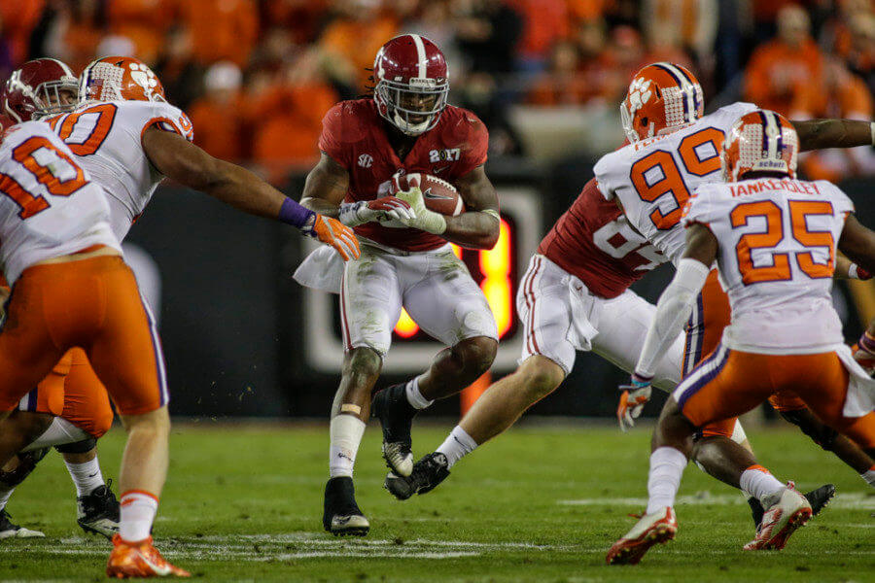

Each school has their own policy when it comes to renewing players’ athletic scholarships after injury. A DI program in a conference that most consider to be less of a powerhouse might not revoke a four-year athletic scholarship, or might transition the scholarship into academics if the player has the grades and effort shown for it. But, a DI program in a powerhouse conference (SEC, Pac-12, Big 10, Big 12, ACC, etc.) has a limited amount of scholarships. Those scholarships are cruicial to putting together excellent football programs with extraordinary athletes. The universities put so much money and effort into programs, and at the bottom sits the players. A fully healthy player may receive a scholarship over an injured player or player held back by current injuries or a history of injuries. This leaves players without athletic scholarships, and a small chance of getting a scholarship at another DI program, and saving their football career.

The NCAA should strongly consider changing the rules for universities and programs so the athletes’ scholarships and injury costs are protected.

If athletes can be dropped easily by universities for injuries, and lose their athletic scholarships and their “free education”, do universities and the NCAA even care for the players’ futures at all?

Beyond College Football
We just looked at how college football players can be abandoned over injuries, and that the NCAA finds themselves not responsible for players’ loss of scholarships and their education. This has led many to believe what happens to college football players and student-athletes in general who do not go on to play professionally? What happens for regular college students and athletes in lower divisions is that they use their four-year education and a college life prioritizing academics to find employment and work towards a stable career. That’s what college is for! But the players are used to people close to them prioritizing athletics. It’s not common by any means that all football players will be set after college. Players’ have futures that need to be addressed. When these players’ focus is football, and they are full-time student-athletes all-year round for four years, how do they have time to plan for life beyond college football?

They don’t have time to plan, and are not prioritizing the main purpose of college which is to learn and plan for a stable future with employment. Thousands of DI football players are unprepared, because they are led to believe they will play professionally and fall short. Or, the players do not have time to plan. They have such a hard time after college and their playing career because there is no program or university guidance helping them. Most universities have career centers which help full-time students find employment after college, and they are very successful in doing so with proper planning and guidance. The full-time players aren’t so lucky…



An article was published in USA Today back in 2011 addressing two University of Missouri football players’ thoughts on the subject of collegiate football players being held back finding employment due to their playing careers. One of them, Jon Gissinger, was a tight end at the university, who knows that less two percent of college players actually go pro. He knew that resumes were important for finding employment after football, and agreed that his playing career didn’t plan for his future because he wasn’t going to play in the NFL. After graduating from his playing days, he understood he was going to suffer due to so much time being focus on playing football for his Missouri program, and no guidance from his program or the NCAA as to what he should prepare for his life after football.
“Every kid has dreams to go pro, and I can tell you I never thought about a job or anything until football was done. A football player is not going to get a job over someone who worked and had internships. My resume right now is football. I’m suffering because I didn’t do volunteering with so much time focusing on athletics. I didn’t do them and they’re essential to get a job or get into grad school.”

-Missouri’s Jon Gissinger to USA Today (8/28/11)

Gissinger is held back because he never thought about a job or career after football, and his playing career is the only thing he has to show for it, when applying in a field where none of his athletic ability matters. He did not have time for activities essential to getting a job or getting into graduate school due to his athletic schedule. Most would blame Gissinger for his problems, because he did not be responsible for focusing on his future and career after football. But the people that should be blamed are the universities and the NCAA for not watching these players closely. He would not be struggling if people took more attention to look at his career plan outside of football, and it is the people to blame in the universities and NCAA for not relieving him of his extensive schedule and for not providing programs to guide him along.

“Not only do student athletes lack the amount of professional experience their peers have coming out of college, they also have less knowledge about their chosen fields. Having no professional experience, Gissinger is still trying to figure out what he wants to do with his life.” – Stephanie Stark

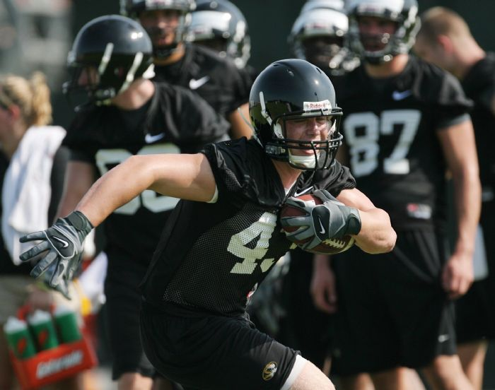

Adrian McBride is also a former Missouri player, who took a different approach. He wasn’t looking at what the univerisities and NCAA should do when the players are in college. He was looking at what should happen once the players graduate from college football. McBride recognized the need for a program that connects ex-athletes to employers. This is why he founded Life After Sports, which was designed to help college athletes make the transition from college to the professional world away from sports. The program has lectures emphasizing the importance of thinking about life without sports, and connecting ex-athletes to “athlete-friendly companies” looking for employes in sales, marketing, and customer service. It was shut down after a few years due to a lack of sufficient followers, which means that people still don’t understand what McBride went through (or Gissinger) and also don’t priotize their careers after football. McBride seems to understand why people don’t think about this, and believes athletes should focus on planning their professional careers and their futures.

“When you’re a freshman, getting a job seems like forever away. It doesn’t hit home with these guys until their life is directly in their eyes and they’re packing Twinkies.” – Adrian McBride

Maybe McBride had a good start by starting programs emphasizing and lecturing the importance of life without sports to current players. His services were shut down because of a lack of followers. However, the universities have large followings of players, as they are actively focusing on athletics all year-round and look first to their university for help. The universities should push for these programs in order to guide players’ towards their future. With the universities not doing this currently, and focusing on academic-first-minded students, the NCAA needs to step in with these programs. If they are serious about prioritizing academics and providing stable futures for these individuals to which they “protect”, they should implement programs guiding the players. It is evident that players don’t care or don’t think about their futures. With many football players struggling to find employment due to the NCAA’s biggest injustice, the NCAA should step in.

Summary
In summary, the NCAA is not doing a good job ruling over the DI football players they are supposed to represent and help. Players are struggling financially, and the NCAA prohibits any players accepting financial aid that doesn’t come from the university programs’ scholarships or federal grants. The restrictions are the result of the NCAA’s theory of amateurism, where players are students first and should not be focusing on compensation they desire. Several players have disagreed with this concept, and it has resulted in many players accepting compensation to which they believe they deserve or need. Scandals have arisen, and it has damaged the reputations of players, programs, universities, and the NCAA, as well as the college football industry in its entirity. The NCAA not compensating its players is a way of showing how they rule against the players, and do not protect them from their needs or care for them as individuals. Another way the NCAA shows their attitude towards football players is by not providing healthcare or pushing for universities to provide protection for their injured players. In what is widely-regarded as the most dangerous sport with the highest injury potential, many players are hurt playing at the collegiate level and must pay injury costs to heal. These injury costs are not covered by the university or the NCAA, even when these players are struggling for more basic necessities. It also results in losses of scholarships when the players cannot perform. Football players believe the NCAA should protect them from the injustices of universities, and also believe they should guide them towards better futures. Most football players do not have time to focus on their careers, as the people around them (including the NCAA) prioritize athletics first. The students call for the NCAA to push universities or implement programs into prioritizing their careers, so they can have time to build strong resumes, find employment, and understand life without sports and life after college football. The NCAA should step up in order to protect the players and guide their futures, when they are living demanding lifestyles.
______________________________________________________
- Conclusion
In conclusion, DI football players are struggling. They have a need
for necessities but lack financials to pay for them. They have
extensive schedules preventing them from working, and covering
their own costs, to relieve them of their problems. When they try to
get by with their limited time, the NCAA restricts them, because of
their belief that players are students first, and should not be
compensated for being student-athletes. Along with self-imposed
restrictions, the NCAA also does not protect the players to which they are supposed to look over. The players are not saved from their injuries, loss of scholarships and education, and from their unplanned future after collegiate football. The NCAA needs to have less restrictions on players, who are limited enough balancing a full-time academic and athletic life. They also need to financially aid the players who are struggling to get by, without their necessities and time for employment to relieve their problems themselves.

This report achieved its purpose in which it illustrates how football players are struggling
without necessary financial aid, and the NCAA being to restrictive and not protecting them.

DI Football Players
Players should receive financial aid from the NCAA for a number of reasons. They are full-time, overworked, underappreciated, unacknowledging, struggling, student-athletes. It is hard for them to balance being an excellent student, and being an extraordinary football player. It’s all even harder, if the players are without necessary food, clothing, living spaces, and other miscellaneous items. Players are hungry, without proper clothing, without living environments, and under lots of financial stress apart from being under the stress of being a full-time student and competitive football player. The players also don’t have time to work due to their extensive schedules. Surveys and testimonies of players in recent years prove that there is no time to work and cover their own costs to which they need items. Players spend so much time on athletic activities each day and week, that they cannot solve their financial stress themselves. The NCAA needs to step up in order to provide compensation and financial aid to the football players in need.

The NCAA
The National Collegiate Athletic Association should provide financial aid to college football players and remove a lot of restrictions. The organization was set up to regulate the college sports industry, govern over universities across the country and programs, and provide a platform for student-athletes (football players included) to compete at the collegiate level. The football players are able to compete while also attain a valued education. However, the football players struggle to do what the NCAA encourages: prioritize academics and excel on the field. The NCAA imposes restrictions prohibiting any football player (financially struggling ones included) from accepting any financial aid that wasn’t received through a scholarship or federal grant. It leads many players who feel they deserve and need compensation to violate their rules, declaring them ineligible by amateurism’s rules, and damaging the reputations of themselves and the universities. The NCAA needs to be less restrictive and more helpful when it comes to the players. Many feel the powerful organization doesn’t care for them, and only sees them as well-off student-athletes. The players need to be protected from losses of scholarships and their injury costs. They also need to provide programs guiding players towards better futures, and helping them find employment. Less restrictions, more aid.
A Change Should Be Made
A reform should absolutely be implemented. The players are struggling, and the NCAA wants to better the college sports industry while saving face. There are two ways a change can be made: self-imposed or forced

Self-Imposed Change

This type of change is the most appealing, because the players get what they want in financial aid from the NCAA, and the NCAA’s doubts of them not caring for the players as individuals disappear. If the NCAA were to provide financial aid to the players, the conversations would end nationwide, and the players would be able to live better off. The struggles would not be present, and the players can focus on their two lives better, while being guided towards a successful and better future in employment outside of football as well.

Fact: The NCAA is a billion-dollar industry, and brings in millions and millions of profits each year.

With their revenue streams, after covering their costs, the NCAA should allocate the same figure mentioned before, $10,000-$20-000, to DI football players in order to get by. The NCAA will not be held accountable if the player doesn’t use that money for all of their needs, the players will be. This allocation is doable by NCAA means, because the “non-profit organization” should be able to allocate money to the players in need just like the universities receive to cover costs and earn revenue through college football. The players will be relieved of their financial stress, if the NCAA were to allocate millions of profits to the people in need of it. Football players would not have to worry about necessities, the NCAA would not have ongoing conversations and doubts about them not caring for the athletes, and the NCAA would stay true to them being a “non-profit organization”.

Forced Change

This type of change will be one-sided in benefiting the players, and even that process won’t be easy or pleasant for the players. If the NCAA will not listen to the players’ needs, there will be a revolution to the system. There are players playing professionally all around the country, who believe the players should have financial aid and programs in place to help them. It is difficult for the NCAA to emphasize with the players, because all of the members do not understand the lifestyle of a current DI football player. The people that understand what it’s like struggling as a player in school, are the professionals, who live easy lives now with no financial stress, and speak up about the injustices of the NCAA. And you can be sure these professional athletes side with the players, and have the platforms and power to make change to the industry.

Seattle Seahawks’ stars Richard Sherman and Michael Bennett made national headlines when they “ranted” against the NCAA during Super Bowl media day. They both gave impassioned speeches about how student-athletes are unfairly maligned and how universities don’t do enough for them. Richard Sherman graduated with honors from Stanford University, earning a degree in communications. He feels the public doesn’t understand how diffiuclt it is for student-athletes today. Sherman’s main points were that students do not have time to take advantage of their free education, have extensive schedules with hours and hours for athletic activities, and how they need money for necessities outside of scholarships.

“I don’t think college athletes are given enough time to take advantage of the free education they’re given. It’s frustrating because a lot of people get upset with student-athletes and say you’re not focused on school and not taking advantage of the opportunity you’ve been given.

I would love for a regular student, for just one semester, to have a student-athlete’s schedule during the season and show me how you balance that. As a student-athlete, you don’t have the kind of time of regular students. You wake up in the morning and have weights. Then you go to class. Then you might get a bite to eat,
then you go to meetings and then you have practice.
And you have to try to get all your school work done.

And people are upset that student-athletes need a little cash. I tell you from experience that one time I have negative 40 bucks in my account. It was in the negative more times than positive. You have to make a decision whether you put
gas in your care or get a meal.

People say you get room and board and they pay for your education. But to the school’s knowledge, you’re there to play football. Those are the things coaches tell you every day. Luckily I was blessed to go to Stanford, a school primarily focused on academics. But as coach Harbaugh would attest, we were still there to play football.”

-Seattle Seahawks’ Richard Sherman
to ESPN (1/29/15)
Sherman passionately brings up a lot of solid arguments, and explains his first-hand account as a former student-athlete. While he may be speaking solely about student-athletes (though he played major conference DI football), he was referring to the NCAA needing to step in and change the industry for players’ benefits.

His teammate Michael Bennett had a more angered approach when it came to the issues facing college football players today. He believes the NCAA is a huge scam, that the players do not get enough credit, and that the NCAA should have financial plans for them.
“I thiknk the NCAA is one of the biggest scams in America.
These kids put so much on the line, it makes me so mad and irate.
Universities need to do more for the student-athletes.

I think the NCAA should come up with a plan for college athletes to receive some of the money they bring into the schools. My school, Texas A&M, I think makes $50 million just on jersey sales. So I would say pay $60,000 to student-athletes for every year you stay in college .Keep that in a 401k, after you graduate, the money is held until you are a certain age and then you get the money.

Regular students don’t understand. When I was in college, I was going to class and some student came up to me and said, ‘I’m paying your tuition’. I said, ‘You don’t pay my damn tuitoin. My mom paid that when she worked two jobs and I woke up eveyr morning at
6 a.m. and worked hard.’ Student athletes don’t get enough credit.”

-Seattle Seahawks’ Michael Bennett to ESPN (1/29/15)
These players are obviously frustrated with the NCAA, and have first-hand accounts of what being a full-time DI football player is like. They know the struggles, the careless-attitudes of the universities and the NCAA, the busy schedules, and that nobody sees it the same way they did and do now. A forced change to the system would occur with current football players joining forces with professional football players. As mentioned before, ordinary players do not have the power to make change while they’re in school, and only star players get national attention. Professional football players definitely have the platforms, the followings, the power, and the personal experience to make real change. They have another very valuable resource that college football players today do not have, and it is the reason for this whole situation: funds.

There’s a process for forced change that connects current collegiate football players and former players:

- Former college football players/professional football players allocate funds from their salaries, and offer financial aid to players at their alma maters.
- Current college football players accept these funds, declaring themselves ineligible by NCAA’s amateurism policy.
- The college sports world takes a massive hit, with thousands of players being ineligble, and programs not being able to compete. Games are not able to be played, and college sports does not earn any of its revenue. The NCAA’s reputation is damaged, and the industry of college football could permanently collapse unless changes are made, allowing the players to be compensated financial aid.
- The NCAA makes exceptions for violations of the amateurism policy by allocating millions of dollars in profits to the players so they can pay for necessities. Rule changes are also made demanded by the players so they have better futures and are protected from the universities’ abuse.

The college football world is a phenomenon enjoyed by millions around the country. However, changes need to be made so the industry stays afloat. Players need to be taken care for by the organization set up to do so. Reasonable financial aid and removed restrictions will benefit everyone. So please NCAA, pay the players…
______________________________________________________
Work Cited

Bhagat, M. (2017, April 12). Reggie Bush Heisman Scandal: Former USC Star Running Back Returns Heisman Trophy. Retrieved November 29, 2017, from http://bleacherreport.com/articles/462705-reggie-bush heisman-former-usc-star-returns-trophy-for-ncaa-ineligibility

Blount, T. (2015, January 29). Seahawks stars rant against NCAA. ESPN. Retrieved October 18, 2017, from http://www.espn.com/nfl/playoffs/2014/story/_/id/12249290/richard-sherman-michaelbennett seattle-seahawks-bash-ncaa

Blytheablythe@newsobserver.com, A. (2017, April 17). Agent pleads guilty to giving money to UNC football players. Retrieved November 29, 2017, from http://www.newsobserver.com/sports/college/acc/unc/article145007249.html

Data, C. (2017, January 5). What's the Price Tag for a College Education? Retrieved November 29, 2017, from https://www.collegedata.com/cs/content/content_payarticle_tmpl.jhtml?articleId=10064

Drotar, B. (2017, May 31). You Could Lose Your Athletic Scholarship. Retrieved November 29, 2017, from http://therecruitingcode.com/you-could-lose-your-athletic-scholarship/

Fish, S. (2014, January 30). From homeless shelters to Super Bowl, Bronco's journey wasn't easy. Retrieved November 29, 2017, from http://america.aljazeera.com/articles/2014/1/30/from-homeless shelterstosuperbowlbroncosjourneywasnteasy.html

Fowler @JFowlerCBS Jul 17, 2014 • 1 min read, J. (2015, June 02). Ole Miss' Bo Wallace: Shabazz Napier was right, players go hungry at night. Retrieved November 29, 2017, from https://www.cbssports.com/college-football/news/ole-miss-bo-wallace-shabazz-napier-was-right players-go-hungry-at-night/

Gaines, C. (2016, October 13). The 25 schools that make the most money in college sports. BusinessInsider. Retrieved October 16, 2017, from http://www.businessinsider.com/schools-most-revenue-college sports 2016-10

Ganim, S. (2014, April 8). UConn guard on unions: I go to bed ‘starving’. CNN. Retrieved October 16, 2017, from http://www.cnn.com/2014/04/07/us/ncaa-basketball-finals-shabazz-napier-hungry/index.html

Gartland, D. (2017, July 31). NCAA rules UCF kicker ineligible for monetizing videos. Retrieved November 29, 2017, from https://www.si.com/college-football/2017/07/31/ucf-kicker-donald-de-la-haye-ineligible ncaa-youtube-videos

Giler, R. (2014, January 18). College athletes say they need pay to cover basic costs of living. Aljazeera America. Retrieved October 17, 2017, from http://america.aljazeera.com/articles/2014/1/18/college athletessaytheyneedpaytocoverbasiccostsofliving.html

Helfand, Z. (2016, September 22). After living in his car, Stevie Tu'ikolovatu has made USC his home. Retrieved November 29, 2017, from http://www.latimes.com/sports/usc/la-sp-usc-tuiklovatu-car-20160922 snap-story.html

Jacobs, P. (2015, January 27). Here's The Insane Amount Of Time Student-Athletes Spend On Practice. Business Insider. Retrieved October 18, 2017, from http://www.businessinsider.com/college- student-athletes-spend-40-hours-a-week-practicing-2015-1

New, J. (2015, May 8). What Off-Season? Inside Higher Ed. Retrieved October 17, 2017, from https://www.insidehighered.com/news/2015/05/08/college-athletes-say-they-devote-too-much-time sports-year-round

News Services, E. (2011, December 22). Ohio State gets one-year bowl ban. Retrieved November 29, 2017, from http://www.espn.com/college-football/story/_/id/7372757/ohio-state-buckeyes-football penalties-include-bowl-ban

Press, A. (2013, September 17). NCAA president: Not a good idea. Retrieved November 29, 2017, from http://www.espn.com/college-sports/story/_/id/9682086/ncaa-budge-paying-college-athletes

Rapp, T. (2017, April 12). Tyrann Mathieu Talks Childhood, Jimmy Graham, More in Men's Journal Interview. Retrieved November 29, 2017, from http://bleacherreport.com/articles/2655683-tyrann-mathieu talks-childhood-jimmy-graham-more-in-mens-journal-interview

Schlabach, M. (2012, January 06). Tyrann Mathieu not running from past. Retrieved November 29, 2017, from http://www.espn.com/college-football/bowls11/story/_/id/7434011/lsu-tigers-cb-tyrann-mathieu helped-shaped-college-football

Solotaroff, P. (2015, August 27). Dez Bryant: The Survivor. Retrieved November 29, 2017, from http://www.rollingstone.com/sports/features/dez-bryant-the-survivor-20150827

Sonny, J. (2017, October 09). 5 NFL Players Who Triumphed Over Their Rough Upbringings To Become Successful. Retrieved November 29, 2017, from https://www.elitedaily.com/sports/5-nfl-players-who triumphed-over-their-rough-upbringings-to-become-successful

Staff, N. (2012, May 10). Report: Cam Newton And Father Admit To “Pay-For-Play” Scandal. NewsOne. Retrieved October 16, 2017, from https://newsone.com/852395/report-cam-newton-and-father admit-to-pay-for-play-scandal/

Stark, S. (2011, August 28). College athletes suffer the greatest injustice from NCAA. USA Today College. Retrieved October 18, 2017, from http://college.usatoday.com/2011/08/28/college-athletes -suffer the-greatest-injustice-from-ncaa/

Walsh, M. (2013, May 01). 'I Trusted 'Em': When NCAA Schools Abandon Their Injured Athletes. Retrieved November 29, 2017, from https://www.theatlantic.com/entertainment/archive/2013/05/i-trusted-em when-ncaa-schools-abandon-their-injured-athletes/275407/

